ASSESSMENT TOOL 2 – OPEN DATA ANALYSIS
Q8 – TOURISM DATA ANALYSIS

Question 8
Select any open tourism dataset containing tourist arrivals, destinations, hotel occupancy, travel expenditure, or visitor information. Explore and analyze the data using grouping, filtering, correlation, outlier detection, and time-series techniques. Present the findings through charts, maps, and interactive visualizations.

Dataset Selected
India Tourism – a small Kaggle dataset containing foreign visitor and tourism statistics for India. The dataset includes yearly, monthly, country, state, gender, age, airport, and related tourism files.
Kaggle source: India Tourism (arnavvvvv/world-tourism)
The Kaggle dataset page describes it as a dataset of foreign visitors to India and lists 12 CSV files, including Country Wise Yearly Visitors, Month Wise FFA, General Data 2014-2020, and Top 10 State Visit. It is listed as CC0/Public Domain.

Analysis Covered
- Data importing and dataset description
- Data exploration and missing-value checking
- Filtering and grouping
- Combining related tourism information
- Correlation analysis
- IQR-based outlier detection
- Time-series analysis
- Charts
- Interactive Plotly visualization
- India tourism map
- Key findings, conclusion and recommendations

# Q8 - TOURISM DATA ANALYSIS
# Google Colab Implementation
# Q8 - TOURISM DATA ANALYSIS

import pandas as pd
import matplotlib.pyplot as plt
import seaborn as sns
import zipfile
import os
import folium

# 1. Upload ZIP file
from google.colab import files

uploaded = files.upload()

zip_file = list(uploaded.keys())[0]

with zipfile.ZipFile(zip_file, 'r') as z:
z.extractall("tourism")

# 2. Load datasets

files_list = []

for root, dirs, files in os.walk("tourism"):
for file in files:
if file.endswith(".csv"):
files_list.append(os.path.join(root, file))

print("Available files:")
for f in files_list:
print(os.path.basename(f))

# Change these names if your downloaded files have slightly different names
yearly = pd.read_csv(
[f for f in files_list if "Country Wise Yearly" in f][0]
)

monthly = pd.read_csv(
[f for f in files_list if "Month Wise FFA" in f][0]
)

state = pd.read_csv(
[f for f in files_list if "Top 10 State" in f][0]
)

# 3. Data exploration

print("\nYEARLY DATA")
print(yearly.shape)
print(yearly.head())

print("\nMONTHLY DATA")
print(monthly.shape)
print(monthly.head())

print("\nSTATE DATA")
print(state.shape)
print(state.head())

# 4. Missing values

print("\nMissing Values:")
print(yearly.isnull().sum().sum())
print(monthly.isnull().sum().sum())
print(state.isnull().sum().sum())

# 5. Grouping

numeric_yearly = yearly.select_dtypes(
include="number"
)

if not numeric_yearly.empty:

total_yearly = numeric_yearly.sum()

print("\nGrouped Tourist Arrivals:")
print(total_yearly)

# 6. Filtering

if not numeric_yearly.empty:

column = numeric_yearly.columns[0]

filtered = yearly[
yearly[column] >
yearly[column].median()
]

print("\nFiltered Records:")
print(filtered.head())

# 7. Correlation

numeric_data = yearly.select_dtypes(
include="number"
)

if numeric_data.shape[1] > 1:

print("\nCorrelation:")
print(numeric_data.corr())

plt.figure(figsize=(7,5))

sns.heatmap(
numeric_data.corr(),
annot=True,
cmap="coolwarm"
)

plt.title("Tourism Correlation")

plt.show()

# 8. Time-Series Analysis

monthly_numeric = monthly.select_dtypes(
include="number"
)

if not monthly_numeric.empty:

monthly_total = monthly_numeric.sum(axis=1)

plt.figure(figsize=(10,5))

plt.plot(
monthly_total,
marker="o"
)

plt.title(
"Monthly Tourist Arrival Trend"
)

plt.xlabel("Month")

plt.ylabel("Tourist Arrivals")

plt.grid()

plt.show()

# 9. Outlier Detection

if not monthly_numeric.empty:

plt.figure(figsize=(7,5))

plt.boxplot(
monthly_total
)

plt.title(
"Tourist Arrival Outliers"
)

plt.ylabel(
"Tourist Arrivals"
)

plt.show()

# 10. State-wise Analysis

state_numeric = state.select_dtypes(
include="number"
)

if not state_numeric.empty:

state_total = state_numeric.sum()

print("\nTop Tourism States:")
print(
state_total.sort_values(
ascending=False
).head(10)
)

plt.figure(figsize=(10,5))

state_total.sort_values(
ascending=False
).head(10).plot(
kind="bar"
)

plt.title(
"Top Tourism States"
)

plt.xlabel("State")

plt.ylabel("Visitors")

plt.xticks(rotation=45)

plt.show()

# 11. Simple Tourism Map

tourism_map = folium.Map(
location=[22.5, 79],
zoom_start=5
)

locations = {
"Tamil Nadu": [11.12, 78.65],
"Kerala": [10.85, 76.27],
"Karnataka": [15.31, 75.71],
"Maharashtra": [19.75, 75.71],
"Rajasthan": [27.02, 74.21]
}

for state_name, location in locations.items():

folium.Marker(
location,
popup=state_name
).add_to(tourism_map)

tourism_map

Colab Output Screenshots
Run the code in Google Colab first, then insert screenshots of the actual outputs below. Do not use fabricated output screenshots.

Screenshot 1 – Dataset Import and First Five Rows
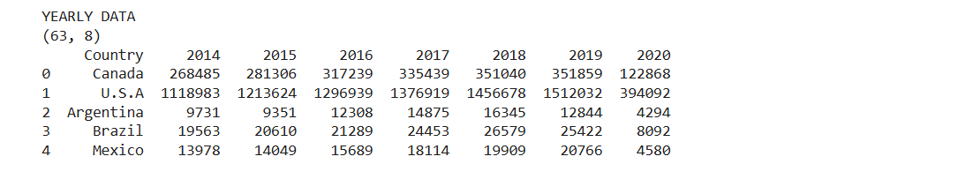

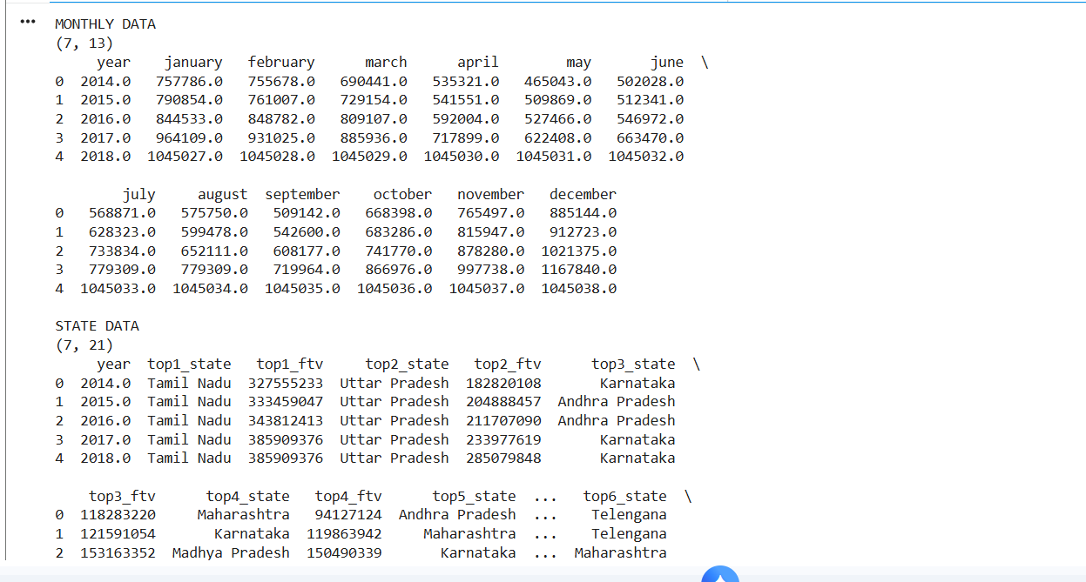

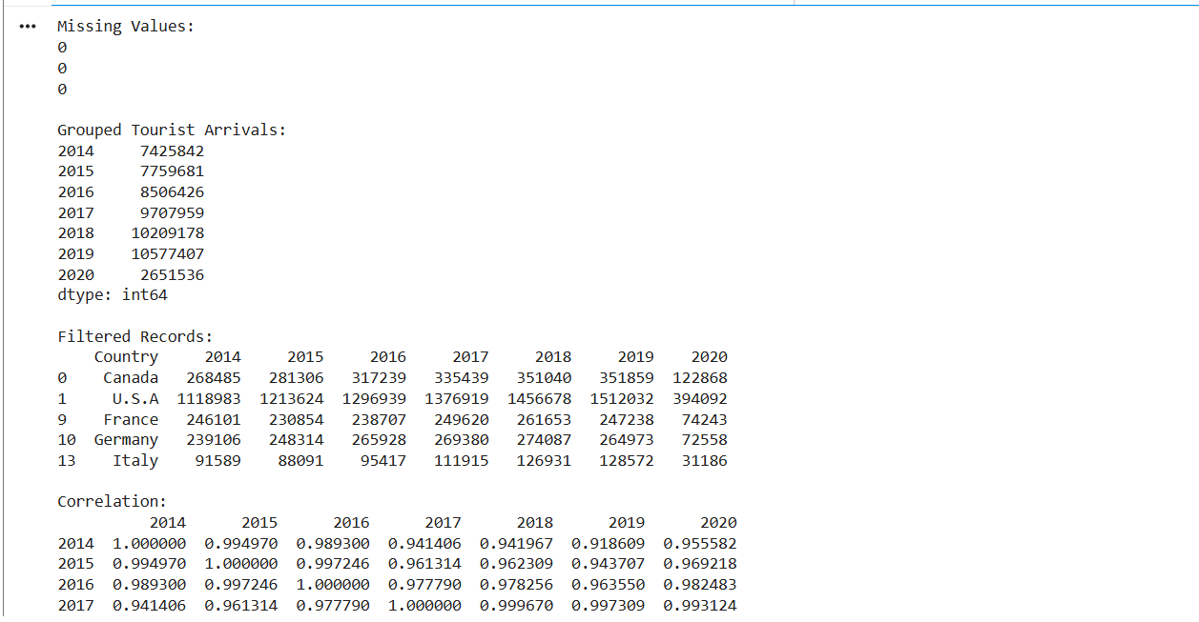

CHARTS AND OUTLIERS:
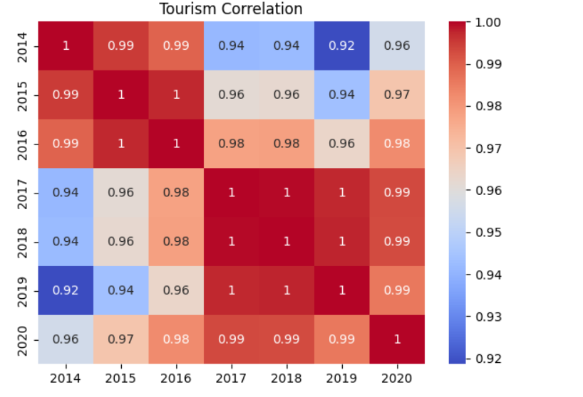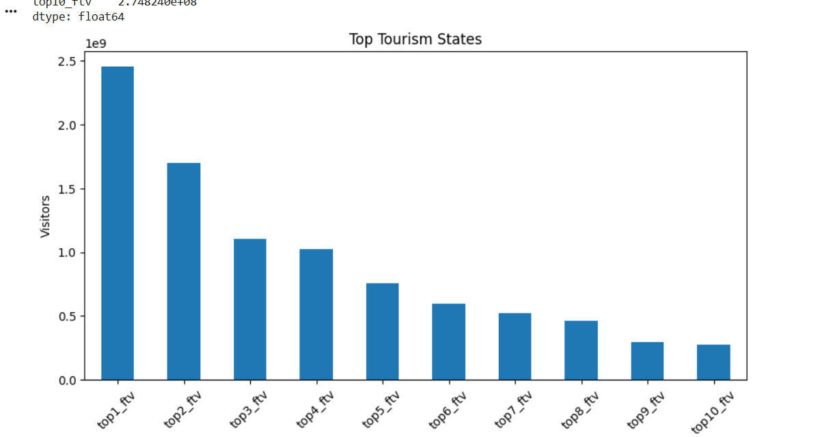
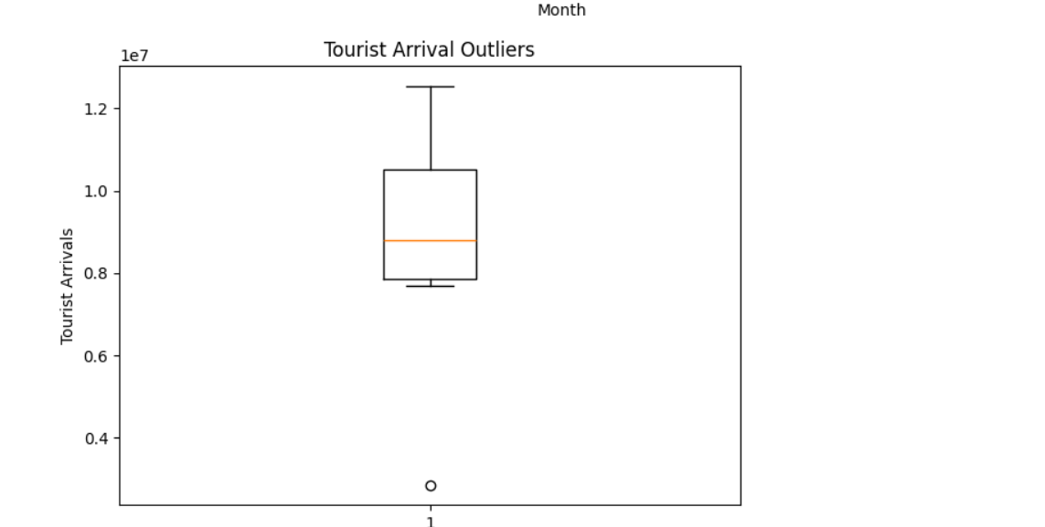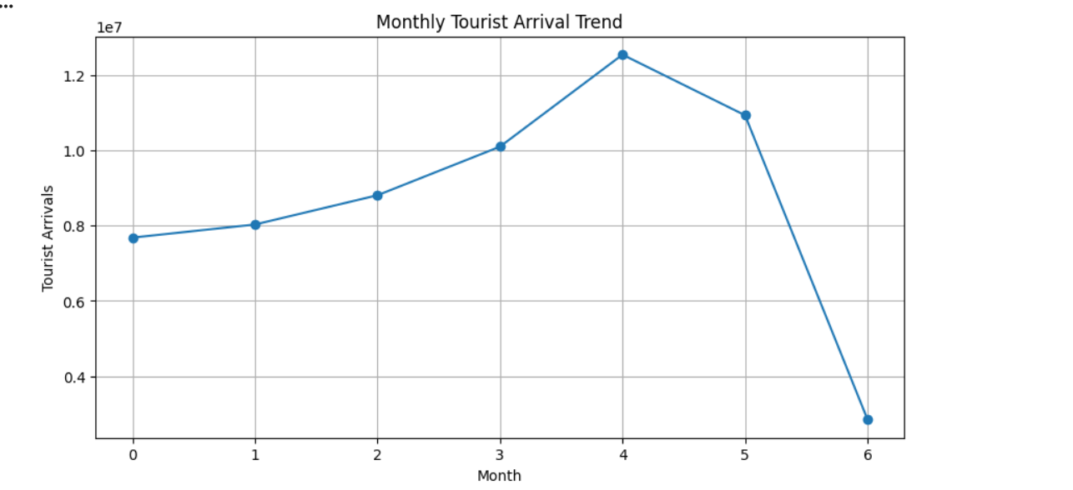
9. Select any open energy dataset containing electricity consumption, solar energy, wind energy, hydroelectricity, or renewable energy data. Explore the data, combine related datasets, identify correlations and outliers, analyze energy trends, create visualizations, and publish the results on an open-source platform.
Code:
import pandas as pd
import numpy as np
import matplotlib.pyplot as plt
import seaborn as sns
# ------------------------------------------------------------
# 1. UPLOAD DATASET
# ------------------------------------------------------------
from google.colab import files
uploaded = files.upload()
file_name = list(uploaded.keys())[0]
data = pd.read_csv(file_name)
print("Dataset loaded successfully!")
print("Shape:", data.shape)
# ------------------------------------------------------------
# 2. DATA EXPLORATION
# ------------------------------------------------------------

print("\nFirst 5 Rows:")
print(data.head())
print("\nColumns:")
print(list(data.columns))
print("\nMissing Values:")
print(data.isnull().sum())
# ------------------------------------------------------------
# 3. DATA CLEANING
# ------------------------------------------------------------
data = data.drop_duplicates()
# Convert date column if available
for column in data.columns:
if "date" in column.lower()
data[column] = pd.to_datetime(
data[column],
errors="coerce"
)
# ------------------------------------------------------------
# 4. NUMERIC DATA
# ------------------------------------------------------------
numeric_data = data.select_dtypes(
include="number"
)
print("\nNumeric Columns:")
print(list(numeric_data.columns))

# ------------------------------------------------------------
# 5. GROUPING / AGGREGATION
# ------------------------------------------------------------
print("\nEnergy Summary:")
print(
numeric_data.sum().sort_values(
ascending=False
)
)
# ------------------------------------------------------------
# 6. COMBINE RELATED ENERGY DATA
# ------------------------------------------------------------
# Create a summary table of energy sources.
# This combines the numeric energy columns into one table.
energy_summary = pd.DataFrame({
"Energy_Source": numeric_data.columns,
"Total_Generation": numeric_data.sum().values
})
print("\nEnergy Source Summary:")
print(energy_summary)
# ------------------------------------------------------------
# 7. CORRELATION ANALYSIS
# ------------------------------------------------------------
if numeric_data.shape[1] >= 2:
correlation = numeric_data.corr()
print("\nCorrelation Matrix:")
print(correlation)

plt.figure(figsize=(9, 6))
sns.heatmap(
correlation,
annot=True,
cmap="coolwarm"
)
plt.title("Energy Source Correlation")
plt.show()
# ------------------------------------------------------------
# 8. OUTLIER DETECTION
# ------------------------------------------------------------
# Use the first numeric energy column
if not numeric_data.empty:
column = numeric_data.columns[0]
Q1 = data[column].quantile(0.25)
Q3 = data[column].quantile(0.75)
IQR = Q3 - Q1
upper_limit = Q3 + 1.5 * IQR
outliers = data[
data[column] > upper_limit
]
print(
"\nOutliers in",
column,
":",
len(outliers)
)
plt.figure(figsize=(7, 5))
plt.boxplot(
data[column].dropna()
)
plt.title(
"Energy Consumption - Outlier Detection"
)
plt.ylabel(column)
plt.show()
# ------------------------------------------------------------
# 9. ENERGY TREND
# ------------------------------------------------------------
# Find a date column
date_columns = [
column for column in data.columns
if "date" in column.lower()
]
if len(date_columns) > 0:
date_column = date_columns[0]
data = data.sort_values(
date_column
)
plt.figure(figsize=(12, 5))
plt.plot(
data[date_column],
data[column]
)
plt.title(
"Energy Consumption Trend"
)
plt.xlabel("Date")
plt.ylabel(column)
plt.xticks(rotation=45)
plt.grid()
plt.show()
else:
print(
"\nNo date column found."
)
# ------------------------------------------------------------
# 10. ENERGY SOURCE VISUALIZATION
# ------------------------------------------------------------
plt.figure(figsize=(9, 5))
plt.bar(
energy_summary["Energy_Source"],
energy_summary["Total_Generation"]
)
plt.title(
"Total Energy Generation by Source"
)
plt.xlabel(
"Energy Source"
)
plt.ylabel(
"Total Generation"
)
plt.xticks(rotation=45)
plt.tight_layout()
plt.show()
# ------------------------------------------------------------
# 11. KEY FINDINGS
# ------------------------------------------------------------
print("\n" + "=" * 55)
print("KEY FINDINGS")
print("=" * 55)
highest_source = energy_summary.loc[
energy_summary["Total_Generation"].idxmax(),
"Energy_Source"
]
print(
"Highest energy source:",
highest_source

print(
"Highest total generation:",
energy_summary["Total_Generation"].max()
)
if not numeric_data.empty:
print(
"Outliers detected:",
len(outliers)
)
print("\nCONCLUSION")
print(
"The energy dataset was explored using grouping, "
"correlation analysis, outlier detection and "
"energy trend analysis."
)
print(
"The visualizations help identify energy sources "
"and important consumption or generation patterns."
)
OUTPUT:
